**Commands**

1. Cal

The command cal in Linux is used to display a simple calendar in the terminal. By default, it shows the current month, but you can use it with various options to display a different year or a specific month.

Syntax:

cal [month] [year]

Command:

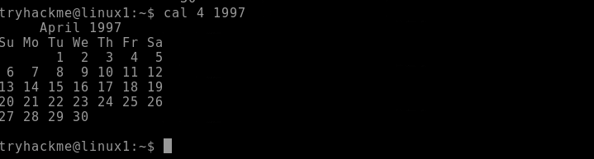

1. Mkdir

The mkdir command creates one or more directories with the specified name.

Syntax:

mkdir [options] directory_name

Command:



1. cd

The cd (change directory) command is used to navigate between directories in the file system.

Syntax:

cd [directory]

Command:

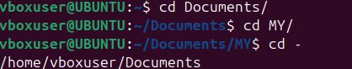

1. pwd

The pwd (print working directory) command prints the full path of the directory you are currently in.

Syntax:

pwd

Command:

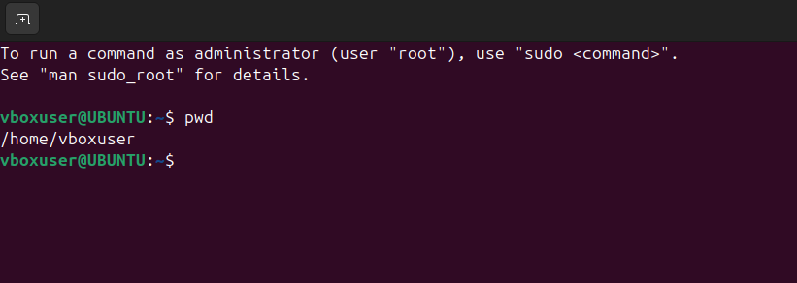

1. ls

The ls command displays the files and directories in the specified directory. If no directory is specified, it lists the contents of the current directory.

Syntax:

ls [options] [directory]

Command:

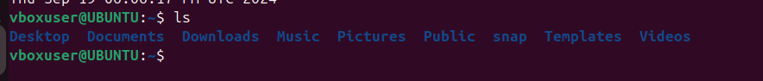

1. whatis

The whatis command shows a brief summary of the function of a command or program from the man page (manual).

Syntax:

whatis [command]

Command:

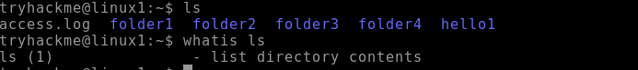

1. find

The find command searches for files or directories in a specified path based on criteria such as name, type, size, and other attributes.

Syntax:

find [path] [options] [expression]

Command:

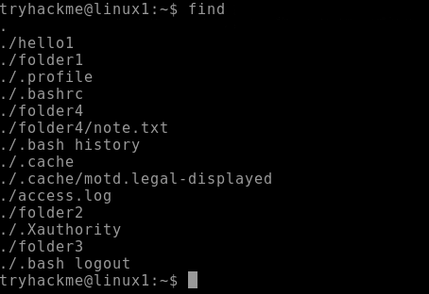

1. rmdir

The rmdir command deletes directories, but only if they are empty. If the directory contains any files or subdirectories, the command will fail unless those contents are removed first.

Syntax:

rmdir [options] directory_name

Command:

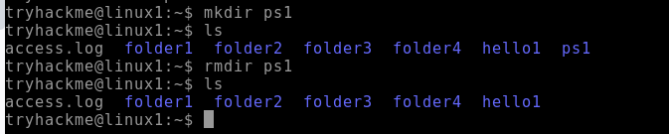

1. echo

The echo command prints text, variables, or outputs results to the terminal or into a file.

Syntax:

echo [option] [string]

Command:



1. cat

The cat command reads files sequentially, writing them to the standard output. It can be used to display file contents, combine files, and create new files.

Syntax:

cat [options] [file...]

Command:



1. whoami

The whoami command prints the effective username of the user who is currently executing the command.

Syntax:

whoami

Command:

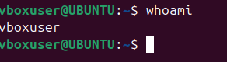

1. cp

The cp command copies files or directories from a source to a destination. It can handle single or multiple files and directories, and it can also overwrite existing files if specified.

Syntax:

cp [options] source destination

Command:

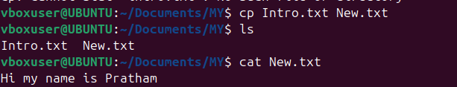

1. mv

The mv command in Linux is used to move or rename files and directories.

Syntax:

mv [options] source destination

Command:

1. head

The head command outputs the first part of files or input data. It is commonly used to preview the beginning of a file or stream.

Syntax:

head [options] [file...]

Command:

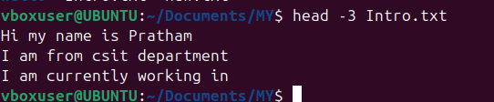

1. tail

The tail command outputs the last part of files or input data. It is often used to view the most recent entries in a log file or to monitor the end of a file for changes.

Syntax:

tail [options] [file...]

Command:

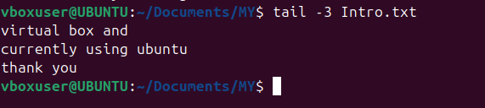

1. sudo

The sudo command grants elevated privileges to run commands that require root or administrative permissions. It's typically used to perform system administration tasks.

Syntax:

sudo [options] command

Command:

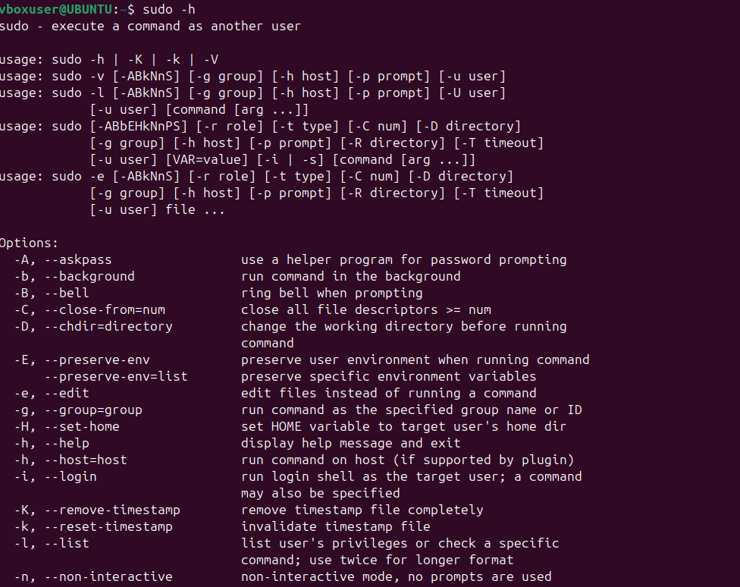

1. ifconfig

The ifconfig (interface configuration) command is used to display or configure a network interface.

Syntax:

ifconfig [interface] [options]

Command:

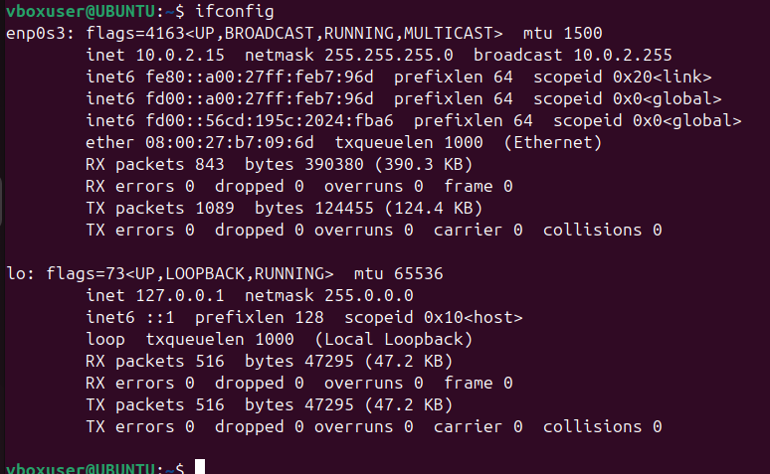

1. more

The more command displays the contents of a file, pausing after each screen of text. It is useful for viewing long files that don't fit on a single screen.

Syntax:

more [options] [file]

Example:

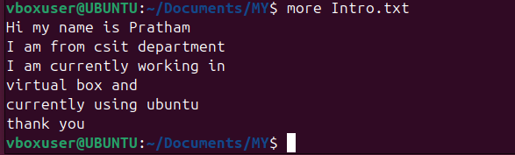

1. ps

The ps command provides a snapshot of current processes, showing details like process IDs (PIDs), terminal associated with the process, CPU and memory usage, and the command that started the process.

Syntax:

ps [options]

Example:

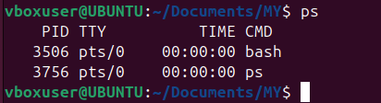

1. cat >

Using cat > filename, you can start typing text directly into a new file. This command redirects the terminal input into the specified file until you signal that you're done.

Syntax:

cat > filename

Example:

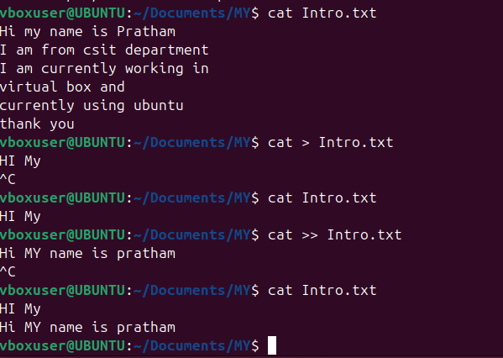

1. cat >>

Using cat >> filename, you can add new content to the end of a specified file. This command allows you to continue writing to the file without overwriting its current contents.

Syntax:

cat >> filename

Example:



1. ls -l

The ls -l command lists files and directories in a long format, showing detailed attributes for each item, including permissions, number of links, owner, group, size, and modification date.

Syntax:

ls -l [directory]

Example:

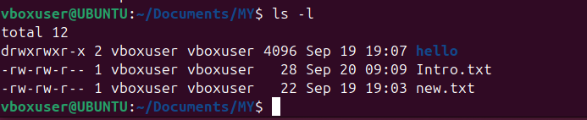

1. ls -a

The ls -a command displays all entries in a directory, including those that begin with a dot (.), which are considered hidden files in Unix-like systems.

Syntax:

ls -a [directory]

Example:

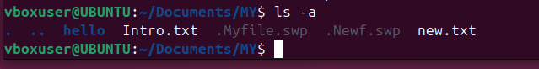

1. touch

The touch command creates a new, empty file if the specified file does not exist. If the file already exists, it updates the access and modification timestamps to the current time without modifying the file's content.

Syntax:

touch [options] filename

Example:

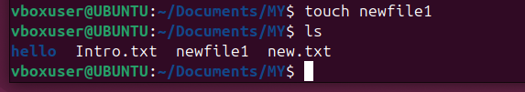

1. ln

The ln command in Linux is used to create links between files. There are two types of links: hard links and symbolic (soft) links.

Syntax:

ln [options] target [link_name]

Example:

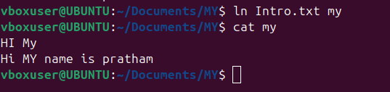

1. date

The date command in Linux is used to display or set the system date and time.

Syntax:

date [options] [+format]

Example:

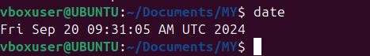

1. netstat

The netstat command provides information about active network connections and network interface statistics, helping users monitor and troubleshoot network issues.

Syntax:

netstat [options]

Example:

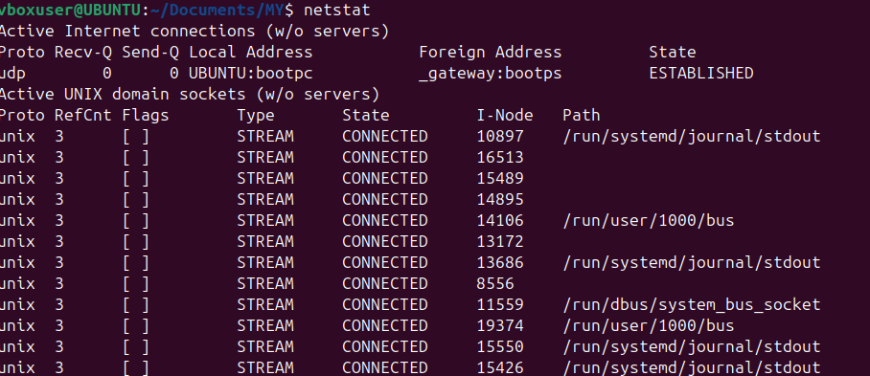

1. gid

In Linux, GID stands for **Group Identifier**. It is a numeric value used to identify a specific group on the system. Each user in Linux can belong to one or more groups, and each group is assigned a unique GID.

Syntax:

id username

Example:



1. chmod

The chmod command allows users to specify who can read, write, or execute a file. Permissions can be set for three categories: the file owner, the group, and others.

Syntax:

chmod [options] mode file

Example:



1. man

The man command is a built-in command that allows users to access the manual documentation for commands, functions, system calls, and other components in Linux.

Syntax:

man [options] command

Example:



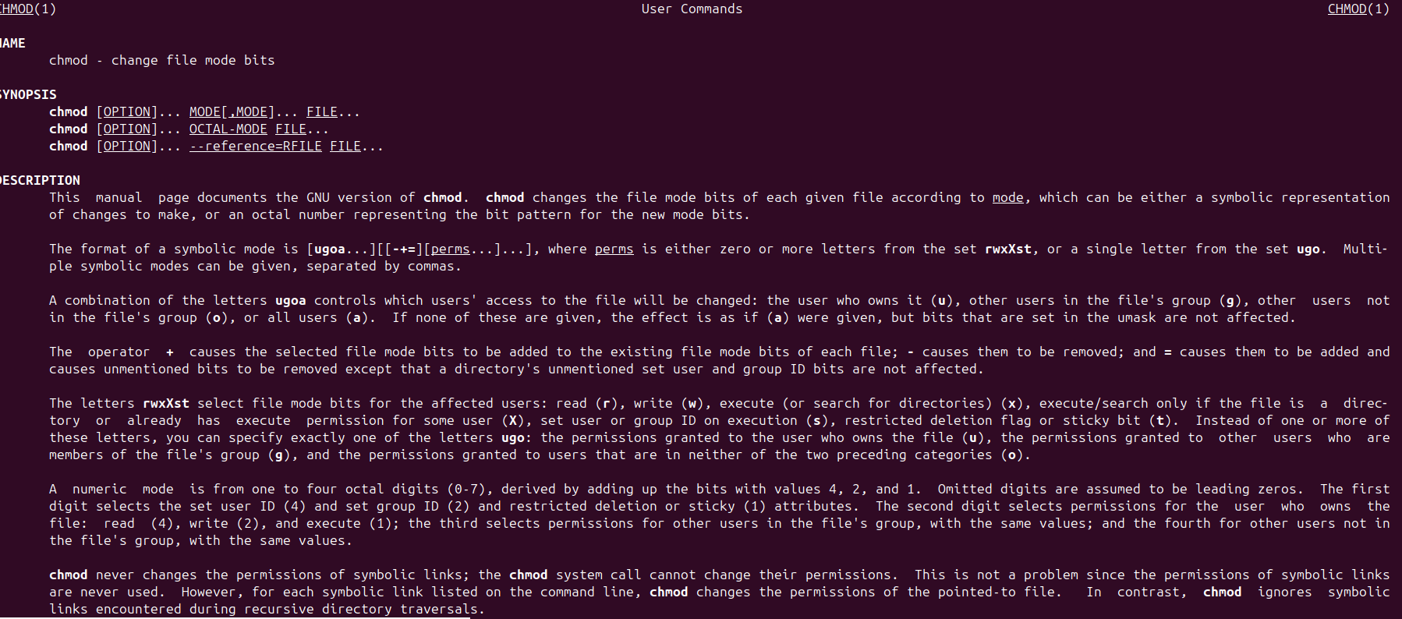

1. rm

The rm command allows users to delete files and directories from the filesystem. It is a powerful command that permanently removes files without placing them in a recycle bin or trash.

Syntax:

rm [options] file

Example:

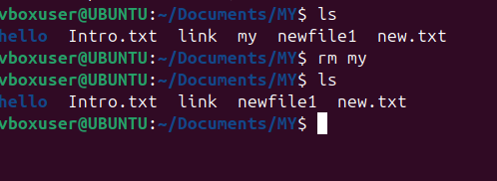

1. rmdir

The rmdir command allows users to delete directories, but it can only remove those that are empty. If the directory contains files or other directories, the command will fail.

Syntax:

rmdir [options] directory

Example:

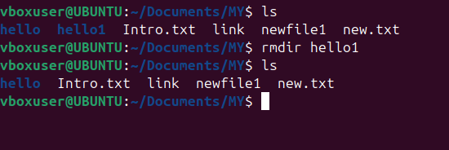

1. less

The less command provides a convenient way to scroll through text files, allowing both forward and backward navigation.

Syntax:

less [options] file

Example:



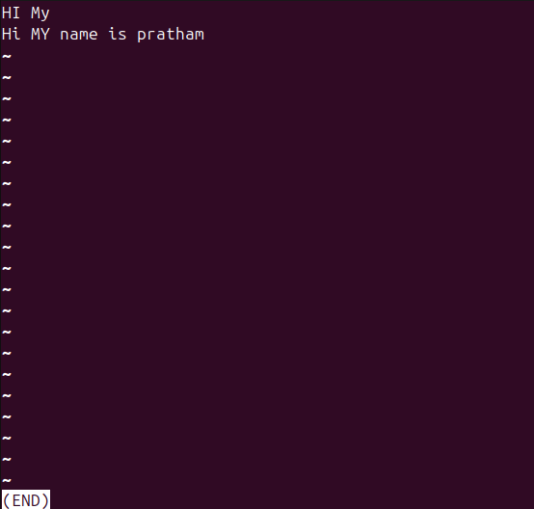

1. grep

The grep command searches through the input (files or standard input) and prints lines that match a specified pattern. It's commonly used for text processing and searching logs.

Syntax:

grep [options] pattern [file...]

Example:

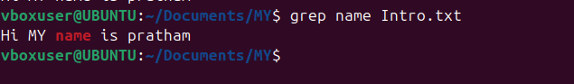

1. locate

The locate command searches for files and directories in a database that contains the paths of all files on the system. This database is typically updated daily by a background service (updatedb), allowing for fast searches.

Syntax:

locate [options] pattern

Example:

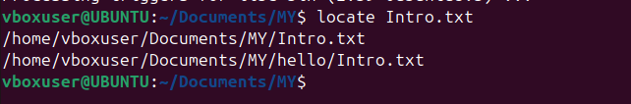

1. sort

The sort command arranges the lines of a file or input in a specified order (ascending or descending). By default, it sorts in ascending order based on the ASCII values of characters.

Syntax:

sort [options] [file...]

Example:

